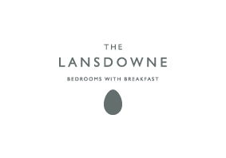

Accessibility Guide for The Lansdowne
Enquiries@lansdownevilla.co.uk, 01451 820 673, Www.lansdownevilla.co.uk
Contact for accessibility enquiries: Gemma Elizabeth Conway
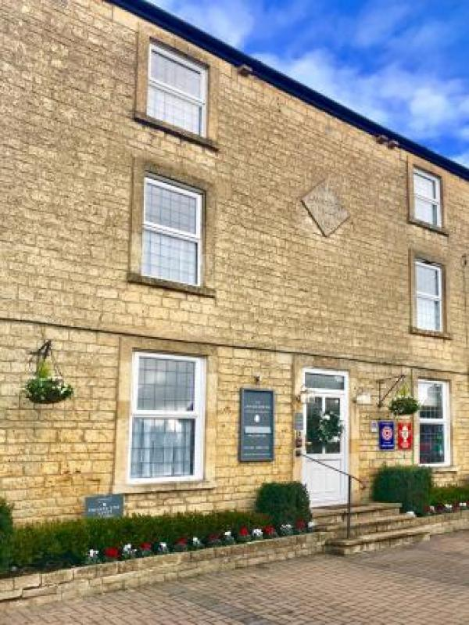

Welcome
We are a family owned guest house in Bourton on the Water we offer beautifully decorated bedrooms all with en suite bathrooms, flat screen TVs, tea and coffee making facilities, free WiFi and free parking on site. We have superior doubles, double rooms, twin rooms and single rooms.

At a Glance

Level Access
- The main entrance has 3 steps and a handrail. There is no lift and no ramp.
- There is level access from the main entrance to:
  - Bedroom: 1
  - Dining Table

Access with steps
- There are steps from the main entrance to:
  - Outside the Guest House

Bedrooms
- We have non-allergic bedding.

Level access bedrooms
- The route to the bedroom is 750mm wide, or more.
- The bedroom door is 750mm wide, or more.
- There is unobstructed floor space 1200mm by 900mm, or more.

Hearing
- The (bedroom) TVs have subtitles.
- Some staff have disability awareness training.

General
- Staff are available 24 hours a day.
- Some staff have disability awareness training.
- We have emergency evacuation procedures for disabled visitors.

Getting here
The Lansdowne
Bourton on the Water
GL54 2AR

Travel by public transport
- You can get to The Lansdowne by bus and train.
- The nearest bus stop to The Lansdowne can be found outside the Londis Newsagents. 801 - Moreton-in-Marsh - Bourton-on-the-Water - Andoversford - Cheltenham 855 - Bourton-on-the-Water - Northleach - Bibury - Cirencester C67 - Stow - Cirencester The bus stop is 0.20 miles / 1,291.1 km from The Lansdowne.
- The nearest train station is Moreton in marsh. The train station is 7.7 miles / 12.4 km from The Lansdowne.
- Great Western Railway
Trains run every day from London Paddington
For train times please visit:
https://www.gwr.com/stations-and-destinations/stations/moreton-in-marsh

Travel by taxi
- You can get a taxi with Andy by calling 07399-722777. The taxi company has a wheelchair accessible vehicle.
- We can arrange taxis for guests if needed. Please contact us directly for more information.

Parking
- We have a car park. There are accessible parking spaces. The parking is less than 50 metres from the main entrance. Parking is free.
- There is a drop-off point at the main entrance. The drop-off point has a dropped kerb.
- From the parking to the main entrance, there are 3 steps. There is no ramp and no lift.
- If you require a disabled space please contact us directly to reserve one before you arrive.
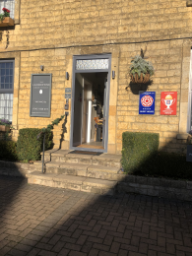
Front door
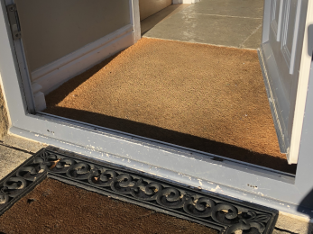
Front door Lip
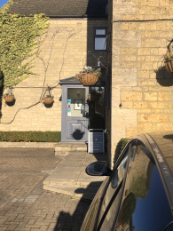
Lower steps to side door
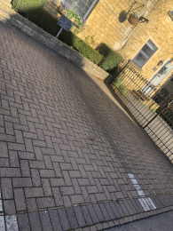
Parking space

Arrival

Path to main entrance
- From the street to the main entrance, there is level access.
- The path is 600mm wide, or more.
- The path is sloped.

Main entrance
- The door is 720mm wide.
- The main entrance has 3 steps.
- This entrance has a handrail.
- The main door is side hung and manual.
Front door
Door lip
Alternative door with lower steps

Getting around inside

Bedrooms
- All bedrooms have windows.
- Bedrooms have ceiling lights, wall lights, bedside lamps and desk or table lamps.
- Lights are LED and energy saving. Some lights can be controlled independently.
- TVs have subtitles.
- All bedrooms are non-smoking.
- We have non-allergic bedding.
- All bedrooms have fitted carpets.
- We can give details of our cleaning products on request.
- We can move the bedroom furniture, to improve accessibility.

Accessible bedrooms

Accessible bedroom 1
- The route to the bedroom is 1000mm wide, or more. The bedroom door is 720mm wide. There is 850mm at the side of the bed. The bed is 630mm high. There is 300mm under the bed.
- The bedroom is double. The bathroom is ensuite. The bathroom door is 720mm wide.
- The bathroom has a separate shower. There is a shower chair available. The direction of transfer onto the toilet is to the right. There is 36mm at the side of the toilet.
- There is 56mm in front of the toilet. The toilet seat is 43mm high.
- The basin is 86mm high. There is no space under the basin.
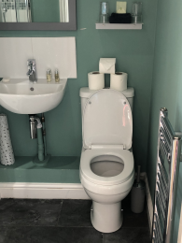
Bathroom
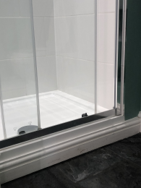
Walk in shower lip

Place to eat and drink

Breakfast room
- From the main entrance to the dining area, there is level access. The route is 720mm wide, or more. The door is 720mm wide.
- To get to a table, there are no steps.
- If you need table service, staff can help you.
- There is background music sometimes.
- The table and plates have high colour contrast.
- We cater for vegetarian, gluten free (celiacs), lactose free (dairy free) and vegan specific diets.
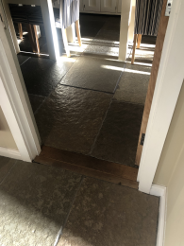
Walkway into breakfast room 1
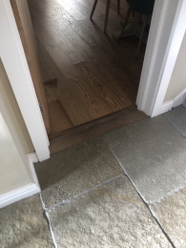
Walkway into breakfast room 2
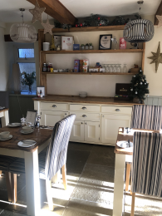
Breakfast room and buffet

Getting around outside

Smoking

Outside the Guest House
- From the main entrance to the smoking area, there are 3 steps.

Customer care support

Accessibility equipment
- We have a portable shower stool.
- We do not allow animals at our guest house.
- We have an area to charge mobility scooters and battery powered wheelchairs.
- We have plugs that chargers can be plugged into in communal areas.
- You can hire mobility equipment from The hearing and mobility shop by calling 01793 815 083.

Customer care support
- Some staff have disability awareness training.
- Staff are available 24 hours a day.

Guide last updated: 2 December 2021

